Michael Good
Advanced Lab I

Discrete Energy Levels in Atoms: The Frank-Hertz Experiment
Abstract
There are energy levels associated with atoms. Quantized amounts of energy can be transferred in emission and absorption. In order to demonstrate the quantum nature of atoms and their energy levels, J. Frank and G. Hertz did an experiment that won them the Nobel Prize in 1925. This report covers three experiments that where performed to investigate the atomic structure of Hg and He similar to the way J. Frank and G. Hertz did theirs. The first experiment is the classic Frank-Hertz experiment. The second is a Frank-Hertz-like procedure to investigate atomic processes in Helium. The final experiment is a spectroscopic analysis of the Helium line spectrum.
Introduction
In 1914, J. Frank and G. Hertz performed a classic experiment in modern physics that verified the quantum theory assumptions concerning the existence of discrete energy levels in atoms. In brief, what they did was accelerate a beam a electrons through a Mercury vapor. When they noticed that the kinetic energy of the electrons reached 4.9eV the Mercury vapor emitted a spectrum line at 254nm. Laying the foundation for a more detailed investigation of the atomic structure of several elements, they took the first steps in the development of scientist’s current understanding of the orbitals in an electron.
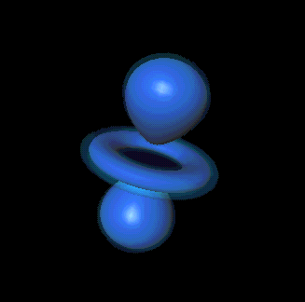Figure 1: The electron d orbital.

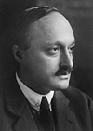
Before 1914, it was well known that excited atoms of the same kind emit a certain spectrum of light, consisting of thin monochromatic lines of varying intensity. Bohr had proposed his model of the atom, where the electron moved circularly about the nucleus with angular momentum in only integer multiples of ħ. This proposal was turning out to be an invaluable clue for better models of the atom as it seemed to explain quite well the emission spectrum of hydrogen. But it was the Frank-Hertz experiment that first offered evidence of atomic quantization that did not involve emission lines. They excited atoms with incident electrons, and discovered that only specific energies were found to be accepted by the atoms. This was implying that the idea of quantization might have much more to do with the world of the small than just emission lines. This experiment directly demonstrated atoms accept energy in discrete bundles rather than just emitting. Perhaps the whole atom itself is quantized in nature? It was suggested that state changes in the atom described the discrete properties of transfer and so it developed from this idea that the world of the small is quantum mechanical in nature.

Picture 1: James Franck and Gustav Hertz smiling for their Nobel Prize which they split.
The basic physics of this experiment is as follows: when an electron encounters an atom it will bounce off without losing any of its energy unless the electron has sufficient energy to cause a change in the internal energy of the atom. Since atomic energy levels are quantized, what happens is that electrons flowing through a gas of atoms with less energy than the first excited state of the atoms will not lose any energy as they travel. On the other hand, an electron with enough energy to cause a transition to an excited state of the atom may induce such a transition with that certain loss of kinetic energy. Such an event is called an "inelastic scattering" of the electron by the atom. This experiment will explore the structure of the atoms in the gas, and the quantization of the energy exchange. It will be seen that atoms will only accept energies at discrete values. These discrete energies will be compared to predictions to verify quantum mechanical assumptions.
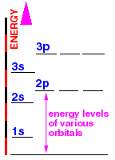
Figure 2: Energy levels.
Theoretical Background
The first two experiments in this lab highly resemble the original experiments done by Franck and Hertz. The measurements done in the first part of the experiment involving the mercury is the most similar, and is actually the original configuration performed by Franck-Hertz in 1914. Besides the use of a computer to analyze measurements, the Franck-Hertz tube remains essentially identical. The Frank-Hertz tube is capable of vaporizing a sample of mercury when heated. The suggested temperature range is 180-210 C for the electrons to be boiled away from a filament within the tube and they are then accelerated towards a collector because the collector is at a lower potential than the accelerating electrode. This is what keeps the low energy electrons away from the collector. As the electrons travel through the mercury there is a chance that they may strike a mercury atom on the way to the collector. Any low energy collision should be completely elastic if indeed there are discrete energy levels associated with the collisions, and this is exactly what occurs. The collector current should not measure much effect for changes in the accelerating voltage, but when the electrons reach an acceleration voltage they have enough energy to excite the mercury atoms. This registers in the collector because the kinetic energy of all the impacting electrons then drops (because give there energy to the mercury atoms to excite them) and the collector does not accept the now low energy electrons. This in turn causes a formation of a maximum in the collector current at or very near this specific voltage. Further increasing the accelerator voltage results in a further increasing current because the electrons begin
to have enough energy again to reach the collector. More kinetic energy losses produce other maxima at even higher acceleration voltages, but the resultant drop in current is now due to many inelastic collisions of the electrons. Because the excitation energy is the same for every maximum then the spacing between each maximum will be same as well.
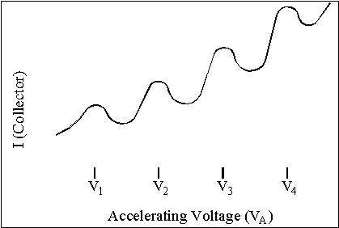
Figure 3: Successive maximum as measured by the collector due to excitation of the mercury atoms.

The second part of this experiment involves helium instead of mercury, but this time the collector is now a loop that picks up stray electrons that don’t make it to the anode in the helium-filled bulb. The collector current measured and plotted has a far different shape because now the electrons excite the atoms and get sucked into the collector loop. When the atoms are ionized there is still a sharp increase in the collector current due to the presence of addition electrons in the bulb. Further non-ionized excitation of helium becomes impossible once the onset of ionization begins, obviously, and the current increases represent excitation energies shown as minima and an early increase in slope.
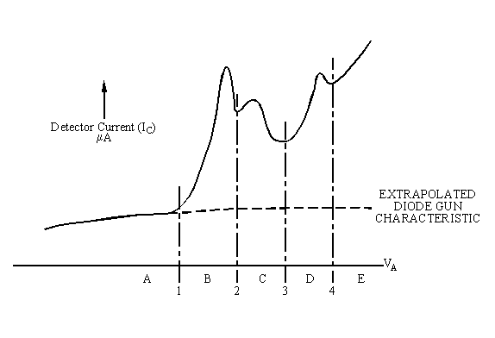
Figure 4: Curve for He gas in a typical Frank-Hertz type experiment as done in part 2 of our lab. Note the differences between Figure 3.

Interesting to note is that the acceleration voltages are not exactly proportional to the energies of the electrons. The current obtained by the electrons creates a contact potential, which is a light charge that screens the full force of the potential that would otherwise be present with just one electron. The data in this lab supposes that that this screening factor is constant over a wide range of accelerating voltages. The differences in accelerating potentials are what is meaningful.

The third part of the lab is a visual observation of the He and Na lines. Using a diffraction grating separates the different wavelength of the light into different angles and allows for measurement. A diffraction grating is basically a large number of fine-line slits close together and utilizes the interference of light to separate it into lines. In this part of the experiment it is helpful to see the relation between the wave length and the m^{th} order angle is
sin(θ) = m(λ)/d [1]
where m = 0 is the center line, λ is the wavelength, and d is the line spacing. This formula is then averaged for the left and right measurements and becomes:
½ [sing(θ_{L}) + sin(θ_{R})] = m(λ)/d [2]
with θ_{L} and θ_{R} being the left and right of center angle measurements.

Experimental Methods
Experimental Apparatus
Let us begin with a discussion on the equipment in this lab. For the first part of the experiment, which is the classic Frank-Hertz experiment, we have the following items:
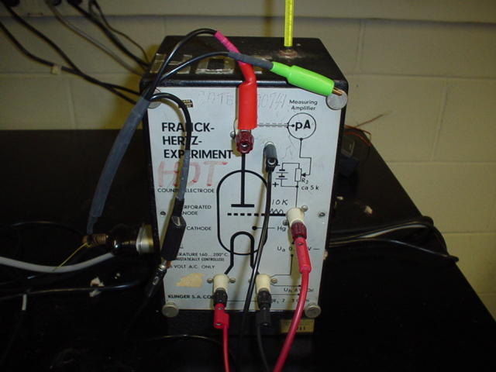 | 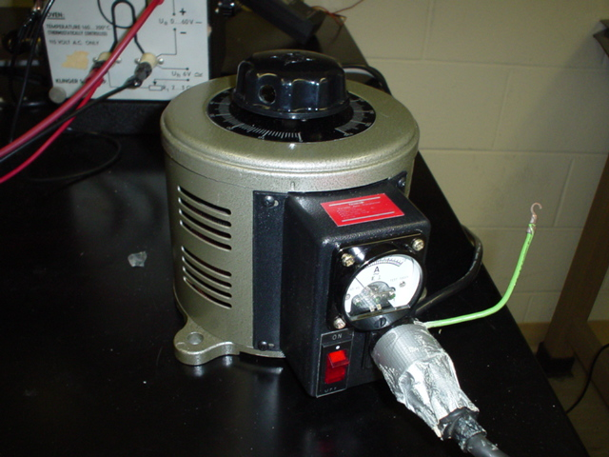
Picture 2: Franck-Hertz tube, Klinger KA6040, filled with Hg and the oven that was maintained at a temperature in range 180 - 210 °C. | Picture 3: The variac that was used to regulate oven temperature. It had to be adjusted several times throughout the experiment to have constant temperature.
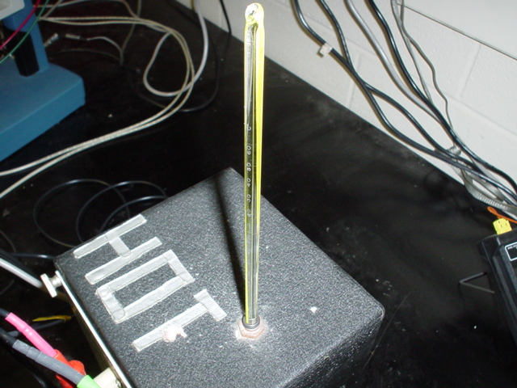 | 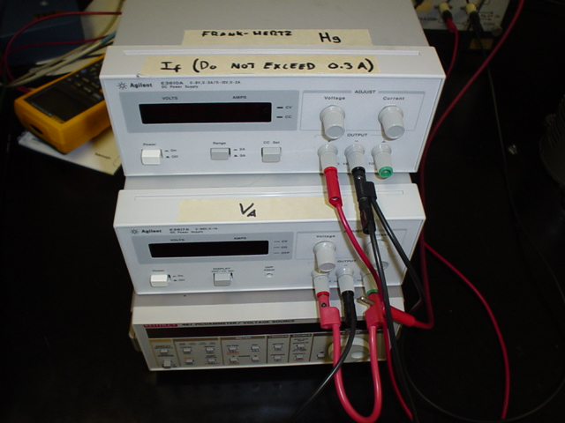
Picture 5: The thermometer, read to be at 200+ °C and the top of the oven which was fairly hot at this temperature from the outside. | Picture 6: Power Supply & Amplifier, Klinger KA6045 which also furnishes filament current and accelerating voltage and maintains collector.

The filament current, I_{f}, is adjustable, and did not exceed 0.3 A. The accelerating voltage, V_{A}, is adjustable by 10-turn pot., that goes from 0 - 70 V. And the collector (M) was about 1 volt negative relative to acceleration. The amplifier was used for detection of collector current, I_{c}; and had a null and sensitivity adjustment. The equipment in Picture 6 included a DC Digital Voltmeter, to measure accelerating voltage, V_{A,} an AC Ammeter, to measure filament current, I_{f}, and a DC Voltmeter, to monitor collector current, I_{c} which monitors output of Klinger amplifier.
For the second part of the experiment, the Frank-Hertz type Experiment with Helium, the equipment used was a Pasco (TEL 533) Helium filled tube, a filament supply, a V_{A} supply, a DC microammeter, a picoammeter and an A-D DAQ board. This equipment is shown in Pictures 7-9. The DC power supply was used to furnish the filament current, 2-3 V, 1-1.2 A, while the DC ammeter was used to measure filament current at 2 A. The accelerating voltage was in the range of 0-45 V and the anode current was at 200 microamps. Last but not least the picoammeter was used to monitor collecting ring current, and its internal architecture requires one terminal grounded.
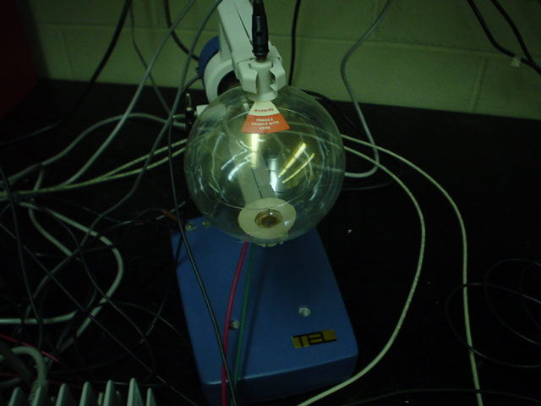 | 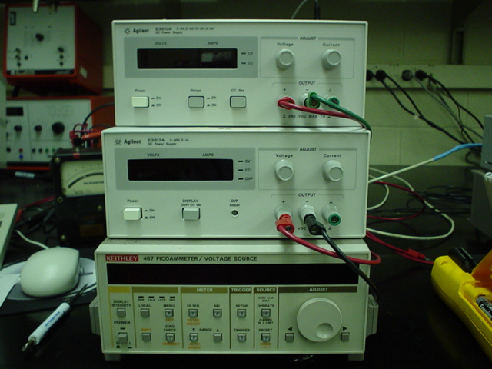
Picture 7: Helium filled tube. | Picture 8: I_{f} supply, V_{A} supply, picoammeter and microammeter.
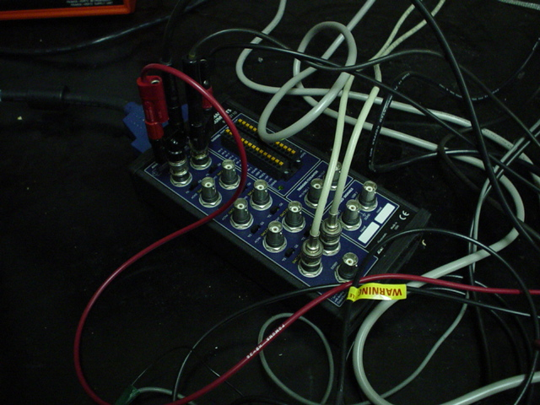

Picture 9: The A-D DAQ board connected to the computer with installed LabView software.

For the third part of the experiment, the Visual Observation of He and Na, the equipment list is nicely short and includes a spectroscope, a diffraction grading, and helium light source and a sodium vapor lamp. These four items are shown below in Pictures 10 – 13.
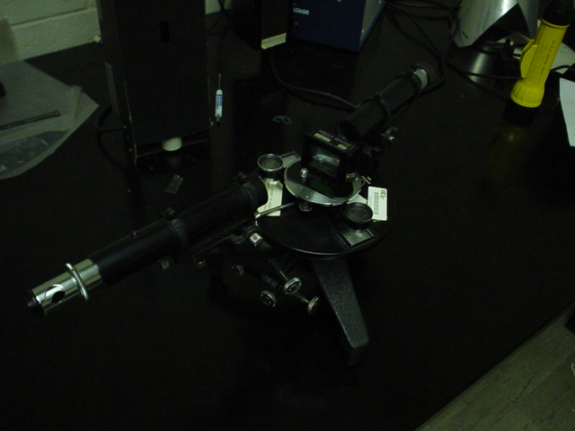 | 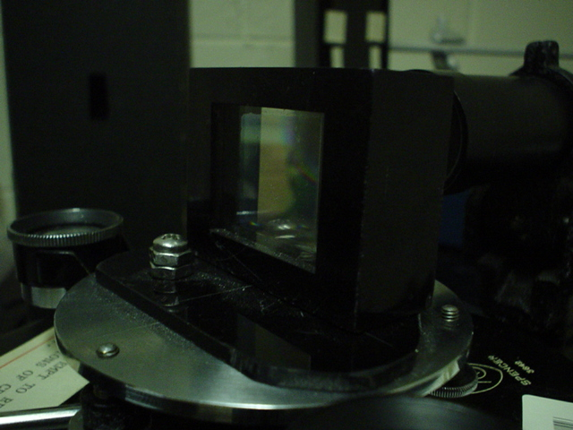
Picture 10: Spectroscope (collimator, table to support diffraction grating, telescope). | Picture 11: Diffraction grating with support.
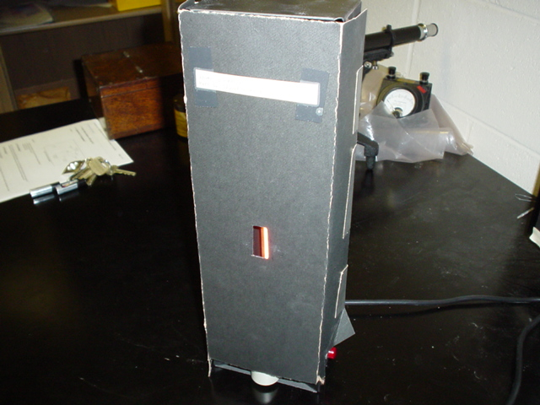 | 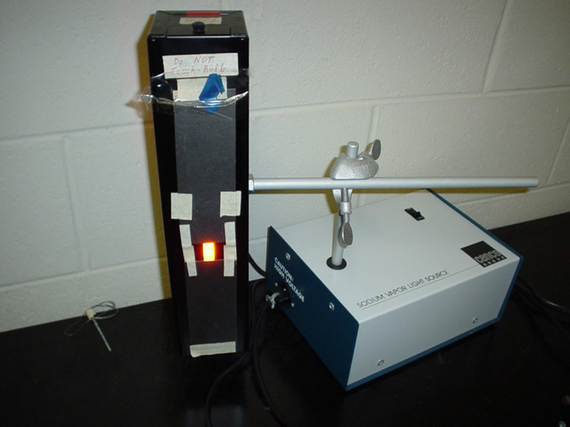
Picture 12: Helium light source. | Picture 13: Sodium vapor lamp.

The sodium lamp becomes hot and it is worthy to mention that if you where to touch the glass lamp, oil from your skin may eventually damage the bulb.
Experimental Procedures
In the first part of the experiment, The First Excitation Potential of Hg, the first thing that was done was opening the Frank-Hertz.vi LabView program. The apparatus switch on the control panel was switched to the Hg experiment. The Frank-Hertz.vi LabView program controls the power supply, and records the current generated as measured by the picoammeter. The control panel has parameters for the voltage increment, starting voltage, ending voltage and scan rate. When the parameters are set and the program run button is pressed the power supply will be run from the starting voltage to the ending voltage in the increments specified. The scan rate determines how quickly the increment will be added. The voltage increment and scan rate was varied to investigate the visible effect on the "quality" of the data collected. Before taking data, the picoammeter was zeroed (by pressing the zero check button) and the range was setup. The meter had several range settings. These settings effect how the picoammeter reports the measured current to its display as well as to the computer (in the form of a proportional output voltage). There are three nano-amp range settings that allow for a maximum reading of either 2nA, 20nA or 200nA. The lower the range setting the better the resolution the meter can provide in that range. When the picoammeter was set to a given range, the switch on the control panel was set accordingly so that the current would be reported accurately. The picoammeter display read "OVERLOAD" when the measured current was above the range setting. It was observed that the data curve remained smooth on the computer display, and this meant that the meter was reporting the current accurately. There was a potential difference between the anode and the loop to increase the collection of electrons. The picoammeter provided this voltage. This was done by pressing the voltage source "Operate" button, then setting the voltage to the desired value. The potential difference between the anode and the loop was set to +0.500V. The location of the peaks in the current was measured and the corresponding voltage was recorded. It is important to note that absolute values of the current are of no importance; only the voltages corresponding to "breaks" in the current are of interest. One good set of data that showed many peaks was obtained and is displayed in Figure 5. The quality and number of peaks was sensitive to oven temperature and filament current. Lower temperature facilitates observation of lower order peaks, but breakdown may occur before higher order peaks can be observed. Reduction in filament current delays breakdown and facilitates observation of higher order peaks. The temperature was set to 200°C the Variac was kept at around 62, while the filament current I_{f} was set at 0.25A. Oven temperature and filament current remained nearly constant throughout the measurement of the data in Figure 5. As the accelerating voltage was increased, distinct peaks not found beyond a certain point was never reached. After many beginning trials fortunately the final data collected was not that of the tube break down. The results where then plotted as a graph in Figure 6 of accelerating voltage for the maxima in collector current versus n, where n is the order of the peak (n = 1 for V about 7 volts, n = 2 for V about 12 volts, etc.). After that the first excitation potential of mercury was determined by the slope of a "best fit" straight line drawn through the data.
For the second part of the experiment, Frank-Hertz type Experiment with Helium, once again the Lab View program was used and the apparatus switch on the control panel was set to the He experiment. The set up was virtually the same as the first part of the experiment. For measurements, the potential difference between the anode and the loop was set to +1.500V. The filament supply was set so the filament current, I_{f}, was 1.10 A. The anode current, with no accelerating voltage (V_{A} = 0), was 10-50 μA. The first minimum, at V_{A} = V₂ = 18-19 V, was fortunately distinctly pronounced, which means that the tube conditions where as desired. A much needed adjustment of I_{f} and fiddling with the equipment was done to meet this criteria and obtain satisfactory data. After any adjustment of I_{f}, the filament was rested for a few moments to allow it to warm up or cool down. Data sets where taken for the entire range (200nA setting) as well as in the area where the first three minima occur (20nA setting). These are shown in the Results section. The results where then put in the form of two plots. One is a plot of I_{C} versus V_{A}, showing the three minima. The initial sharp increase in collector current is not associated with a minimum. The second plot made was a semi-log plot of I_{C} versus V_{A}, with I_{C} on the log axis. Only the region where I_{C} is small was covered, and enough range is shown so the abrupt initial increase in I_{C} is at V_{A} = V₁. From the plots the voltages at which abrupt increases in collector current appear, V₁ .. V₄ were then estimated. These abrupt increases in collector current signify the onset of atomic processes in which the He atom atoms absorb energy from the electrons, i.e., excitation or ionization. The resultant low energy electrons are attracted to the collector loop.
For the third part of the experiment, The Visual Observations of He and Na an alignment of the spectroscope was the first thing done. Adjustment of the eyepiece of the telescope was done for sharp images of the slit and the crosshair. The spectroscope was already aligned fortunately, so the alignment process was unnecessary. From there angular measurements were in fact very simple to accomplish. The measurements of the angles were done using the vernier on the spectroscope scale. This part of the experiment was divided into three parts of observations. They are as follows:
Sodium spectrum, first order. A trial and error procedure, that took the most time, consisted of rotating the table supporting the grating until the right and left deviations, θ_{r} and θ_{l}, are equal to within a few minutes. The grating space, d, was then determined from these data by use of the grating formula, equation [2].
Sodium spectrum, second order. This part was a measurement of angular deviations, in second order, for both members of the sodium doublet. The angular separation of the members of the doublet was measured carefully. From these data, the separation in wavelength between the members of the sodium doublet was estimated. Equation [3] was used to do this.
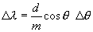 | [3]
Helium spectrum, first order. This was also a measurement of angular deviations to the right and to the left, of the center line. The data was used to determine wavelengths of the lines which are relatively bright in the helium emission spectrum.
Results
First Excitation Potential of Hg
The best set of raw data obtained by the LabView program is displayed in Figure 5 below as a plot of accelerating voltage versus collector current. Its general shape is happily similar in shape to the plot in Figure 3.

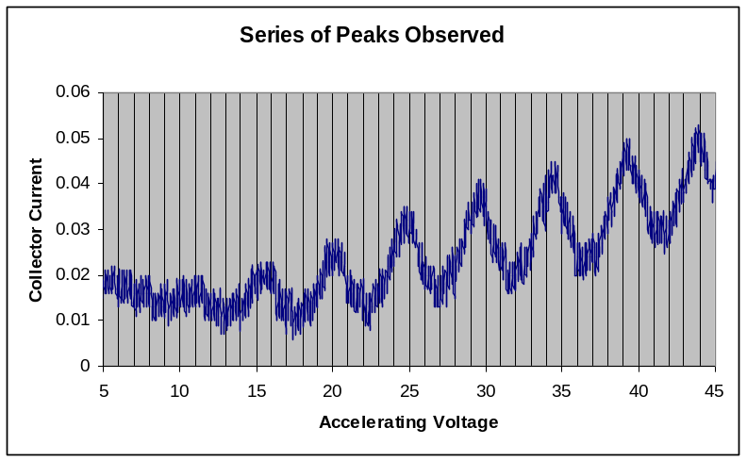
Figure 5: Excitation Peaks of Mercury

Note the relative fuzziness of the lines in Figure 5. This jittering of data points could have stemmed from a number of causes but since parameters were kept constant and as a whole the random motion can be considered a box with a half-width of about .50 V in the accelerating voltage direction the error was chosen to be simply half of the V_{A} half-width. A value of +/- .250 V. The error involved in such a measurement would ideally be related to the curvature of a maximum but these measurements where not taken. The choice of n matters for the slope of the regression line to the data in Table 1, where the relative differences in n only count.
n | V_{A} (V) | Error(V)
1 | 10.50 | .250
2 | 15.50 | .250
3 | 20.05 | .250
4 | 25.05 | .250
5 | 29.60 | .250
6 | 34.40 | .250
7 | 39.15 | .250
8 | 43.95 | .250
Table 1: Hg Maxima Data, n is the order of peak

The excitation energies of the mercury gas should be related to the same fundamental excitation energy, thus the difference in the acceleration voltage between any points should be a multiple of this excitation energy. A best fit of this excitation energy is the least-squares fit line regressed against the data in Table 1. The slope of the line is the energy difference. The error bars are there, but they are too small to see clearly.
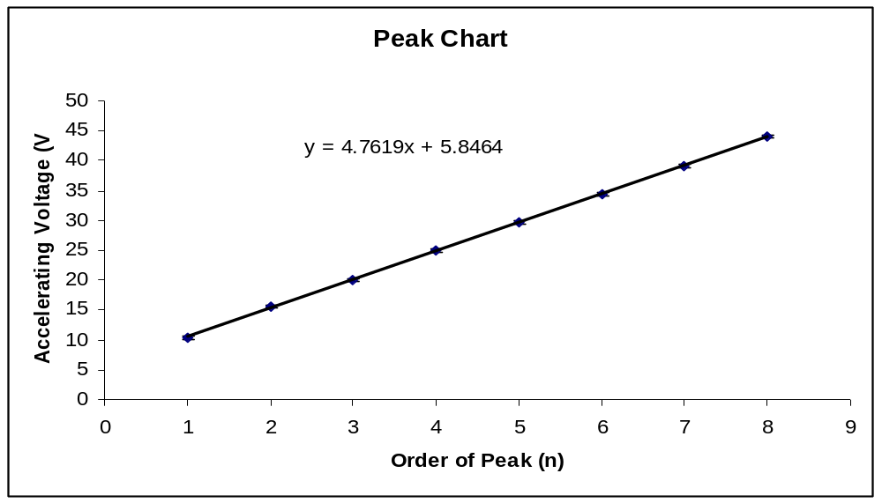
Figure 6: Plot of accelerating voltage for the maxima in collector current versus n.
The line is nearly a perfect fit to the data points and the standard error is +/- 3.36 x 10⁻⁵ . For an error of 2.8% of the expected slope of 4.9 V. What is seen is that the series of dips in the current at the collector with a spacing of about 4.8 V, correspond to the excitation energy of about 4.8 eV. The existence of quantization of energy in the states of these atoms is implied and this sort of result no doubt strongly convinced scientists in the early 20th century to embrace and explore quantized theories and explanations of the microscopic world.
Helium Frank-Hertz Experiment
The results are to be put in two plots, one as a plot of I_{C} versus V_{A}, showing the three minima, in Figure 7, and the other as a semi-log plot of I_{C} versus V_{A,} with I_{C} along the log axis. But unfortunately the semi-log plot is impossible with negative numbers as data points read from the LabView program. The area where I_{C} is small should include enough range that the abrupt initial increase in I_{C} at V_{A} = V₁, but this initial segment of abrupt increase was also not possible to see despite numerous consistent readings that resulted in negative values for collector current. The error associated with this is unknown, but could have resulted from faulty readings from the equipment which where seen in attempts to receive the type of graph shown in Figure 7.
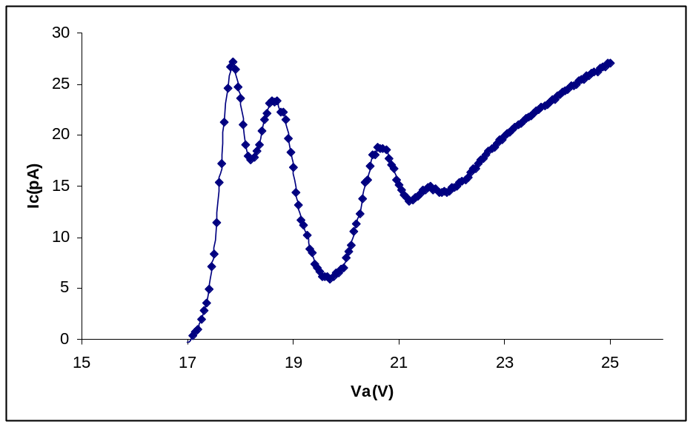
Figure 7: Plot of I_{C} versus V_{A}.

The least accurate measurement, due to a lack of precise conditions is the excitation of V_{A} associated with the first sharp increase in collector current. The error in this part of the lab can be extrapolated further than the previous error analysis due to extra data taken around each minimum. If the data curve is taken to be roughly a parabola near the minimum and I_{C} is assumed to be found within .005pA, then the approximate error in V_{A} can be found. Using I_{C} = b(V_{A})², with zero at the extremum, the deviation becomes (ΔV_{A})² = | 0.005/b |, where b is a scaling factor that is easy to find.
V_{A} (V) | Error(V)
16.95 | .109963
18.20 | .306916
19.70 | .573841
21.25 | .407123
Table 2: Excitation Potentials for He
These abrupt increases in collector current signify the onset of atomic processes in which the He atoms absorb energy from the electrons, that is, excitation or ionization. The resultant low energy electrons are attracted to the collector loop. This helium experiments when compared to the mercury version runs into some difficulty when explaining the minima in the graphs. With mercury a single excitation energy was responsible for all the minima, whereas the data for helium does not indicate such a single excitation energy. A common excitation energy could be suggested from Table 2, but if this was done, several minima would be expected to happen in the initial segment of the collector current. These minima were not observed, and if the lowest energy excitation potential for this experiment where used, there is not indication of a multiple close to this energy, (it does in fact occur above 30 eV and this data was observed and displayed in Figure 8 for interest.
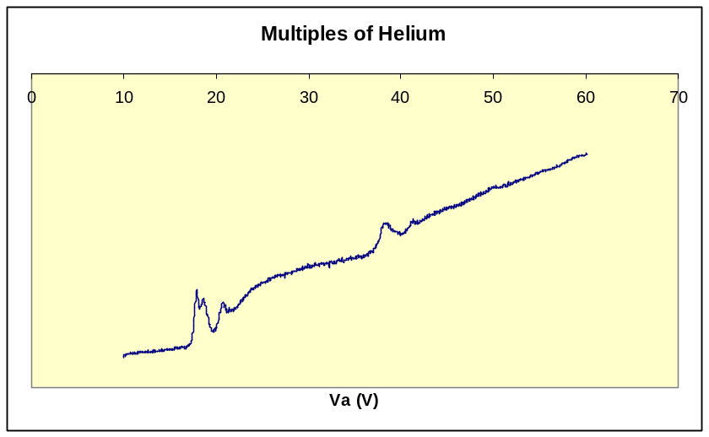
Figure 8: The higher multiples of Helium.

The x-axis was observed to have negative values for collector current and so was left out, but the shape of the graph is what is of interest, as it shows another dip around at around twice the first excitation. From this observations each one of the excitation potentials in Table 2 should represent independent excitations that are not the result of multiple collisions. The accepted values for the principal energy levels of helium are 19.8, 20.9, 22.9, and 24.6 eV. The excitation potentials should be the result of exciting a ground-state electron to some higher-energy orbital. A shifting factor could be introduced to help see that roughly the values fall within the range of accepted values, but this is unnecessary because the resolution of the apparatus is not good enough to distinguish between closely spaced atomic energy levels. The reason for the shifting factor would be to compensate for the contact potentials. Therefore, a qualitative interpretation of the data was all that was needed. Taken as a whole, the data appears to correlate well to the accepted excitations.
Visual Observations of He and Na
The standard spectral notation consists of two quantum numbers that describe orbital energies that neglect spin. The principle quantum number, n, and the length of the angular momentum vector, l. For l = 0, 1, 2, the letters s, p and d are used. The orbital n = 2, l = 1 the notation is simply 2p. Helium electrons either have parallel spin or non-parallel spin. Configurations with parallel spin have a higher energy state than in an anit-parallel state. Both electrons cannot reside in the lowest shell due to the Pauli exclusion principle, therefore further notation is needed. Parallel spin configurations are called triplets, while anti-parallel configurations are called singlets. It is assumed that one electron is always in the 1s orbital so that the orbital of the excited electron is of interest. The use of a superscript after the n quantum number is used to indicate triplets or singlets, i.e. n = 2, l =1 triplet configuration is summarized using 2³p. Of course the other elements demand more complicated notation, but for helium this is sufficient.
Sodium spectrum, first order:
The zero angle was 20.10 degrees and the angle measurements are all relative to this zero. The grating was adjusted as a suggestion to be 2 minutes difference between the right and left measurement for the first yellow sodium line, while the error is placed at +/- 2.83 minutes taken from 2 minutes to be the expected random error of measurement and 2 added in quadrature, where 2.83 minutes is 0.0471 degrees. The measurements of the sodium 589.3nm line from the right and left are shown in Table 3.

Direction | Degrees
From the Right | -20.450
From the Left | 21.260
Table 3: First Order Measurements of Sodium 589.3 nm Line
Using [1] a more accurate measurement found though first order line measurements of sodium can be done to determine the experimental value of the grating spacing, d. The number displayed on the grating has problems because of mechanical reproducibility. Using m = 1 in equation [1] d can be solved for and is found to be 1655.69 nm. Taking the derivative will get an estimate for the error equal to Δd = λ (cos(θ)/sin²(θ)) Δθ. Using the error for Δθ = .000823 / 2 because its an average, our final d value becomes
d = 1655.69 +/- 1.79 nm
Such a small error indicates that d is fairly well known and the error will be ignored in the rest of the calculations.
Sodium spectrum, second order
The second order sodium spectrum lines have the same zero and same error as the first order lines, but the error in separation is less related to the zero-point error or such errors and far more related to angle measurement error. This random error is taken to be 2 min = 0.0333 degrees. Table 4 shows the doublet line angle measurements. The first order line where not separated.
Direction | Lines | Degrees | Difference
Right | 1st | -45.310 | ~4.8 mins
Right | 2nd | -45.390 | ~4.8 mins
Left | 1st | 45.350 | ~5.4 mins
Left | 2nd | 45.440 | ~5.4 mins
Table 4: Doublet Lines, Angle Measurements of Sodium 589.3nm
The separation in wavelength between the members of the sodium doublet follows from the grating formula, equation [3]. Using this, m =2 , d is known from above, 1655.69nm, and Δθ is (5.4 + 4.8)/2 = 5.1, and θ is the average value for the sodium doublet angles, 45.37 degrees. Thus the separation is estimated at .8625 +/- .1695 nm, with an error of 19.6%. The accepting error in Δθ was +/- 1 min. This error is large, but expected because of the resolution of the equipment used to measure by eye the separation of such small separations. Even though, it is to be noted that there is a fine structure in an atom not related to the quantum numbers n or l. This is a result of spin and its alignment with other particles that create energy differences effecting the separation in wavelength. Transitions of electrons from one orbital to another differing only in spin will produced two slightly different energy/wavelength of emitted photons, and this difference is just enough to detect! (in this case using sodium).
Helium spectrum, first order
The data collected in this part of the visual observations are used to determine the wavelengths of the lines which are relativity bright in the helium emission spectrum. The zero was found to be 19.9 degrees and all measurements are again relative to it. The error is the same as in the first order sodium lines.
Line | Average of Right and Left Degrees
1 | 15.660
2 | 16.500
3 | 17.290
4 | 17.640
5 | 20.770
6 | 23.790
7 | 25.220
Table 5: Helium First Order Line Measurements

The wavelengths are calculated in the same way as previously done and displayed in Table 6. The emission lines of helium are displayed in Figure 9 as given in the lab handout.
Lamda | Avg. Observed | Change | Error | Classification
447.7890 | 447.1577 | 0.6313 | .6670 | 2p-4d
471.8878 | 471.3382 | 0.5496 | .6530 | 2p-4s
492.1948 | 492.2190 | 0.0242 | .6615 | 2p-4d
501.8587 | 501.5799 | 0.2788 | .6572 | 2s-3p
587.7216 | 587.5431 | 0.1785 | .6322 | 2p-3d
668.5089 | 667.8207 | 0.6882 | .6167 | 2p-3d
707.1309 | 705.9782 | 1.1527 | .6481 | 2p-3s
Table 6: Wavelengths and Classification of emission lines of Helium.

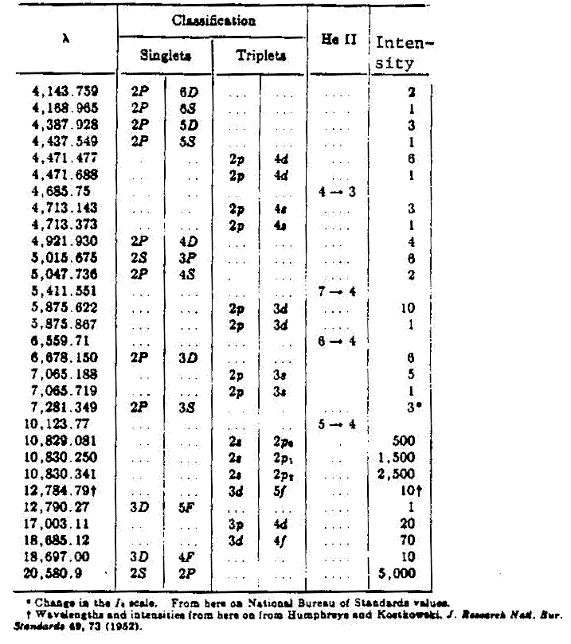
Figure 9: The Spectrum of Helium I and II
It must be mentioned that the spectral lines for helium represent discrete energy changes predicted by quantum mechanics. The bound electrons are in a non-continuous energy spectrum and move only between discrete energy states. This is happily what we wanted to observe and clarify.
Discussion and Conclusions
From the first part of this experiment it was shown that Hg atoms respond to stimulation from incident electrons and accepted energy in multiples very close to the accepted value. Excitation potentials in mercury gas were found to be the result of transitions of ground-state electrons to higher principle quantum numbers and eventual ionization of the atom. Discrete minimum excitation energies exist, and the example of mercury helps to prove this and suggests more exploration of this quantum behavior is favorable. Examination of the spectra of helium support predications in quantum mechanics about the energy differences of orbitals. To strongly iterate this point again, evidence was found that energy is exchanged in quantized bundles. Also energy associated with fine structure in the second order sodium lines gave evidence that spin was present because the scale of energies where below the typical energies found for orbital transitions.


As an interesting note the German stamp to the right commemorates James Frank with Max Born. Both were Nobel laureates, friends for life, and expatriates. Max Born's work in quantum mechanics was at a time when both Heisenberg and Schrödinger developed their formalisms. He linked wave mechanics with probability by interpreting the square of the wave function as a probability density.

